MIS 6360

Agile Project Management

Group Research Midterm Project

Group 11

Prepared By:

Soumya Ranjan Mishra

Akshay Raj

Prashant Shivaji Bhapkar

Rutwika Mohanty

Question 1 (40 points)

a. Create the project described in table 1 in Microsoft Project and paste a screenshot of the bar (Gantt) chart of the project highlighting the critical path below. Please make sure all tasks are clearly labeled with their corresponding task name.

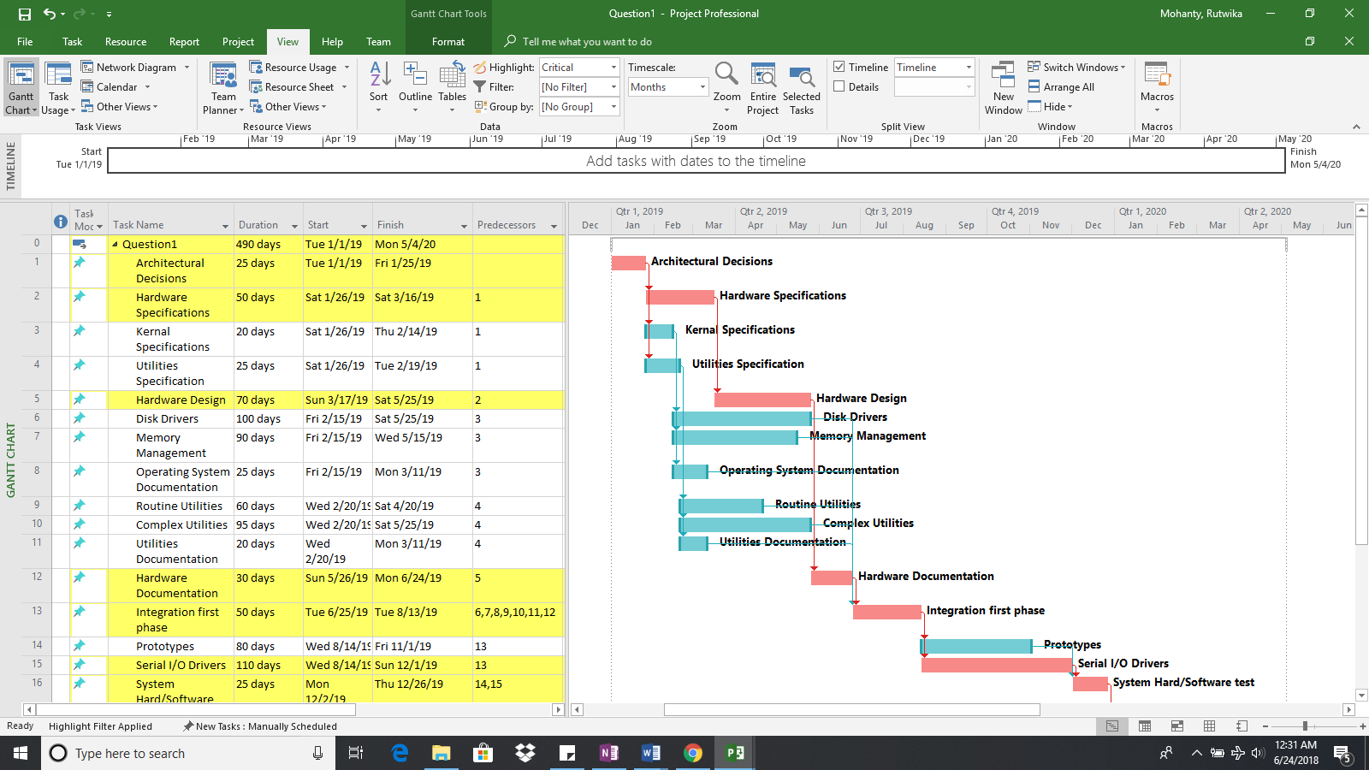

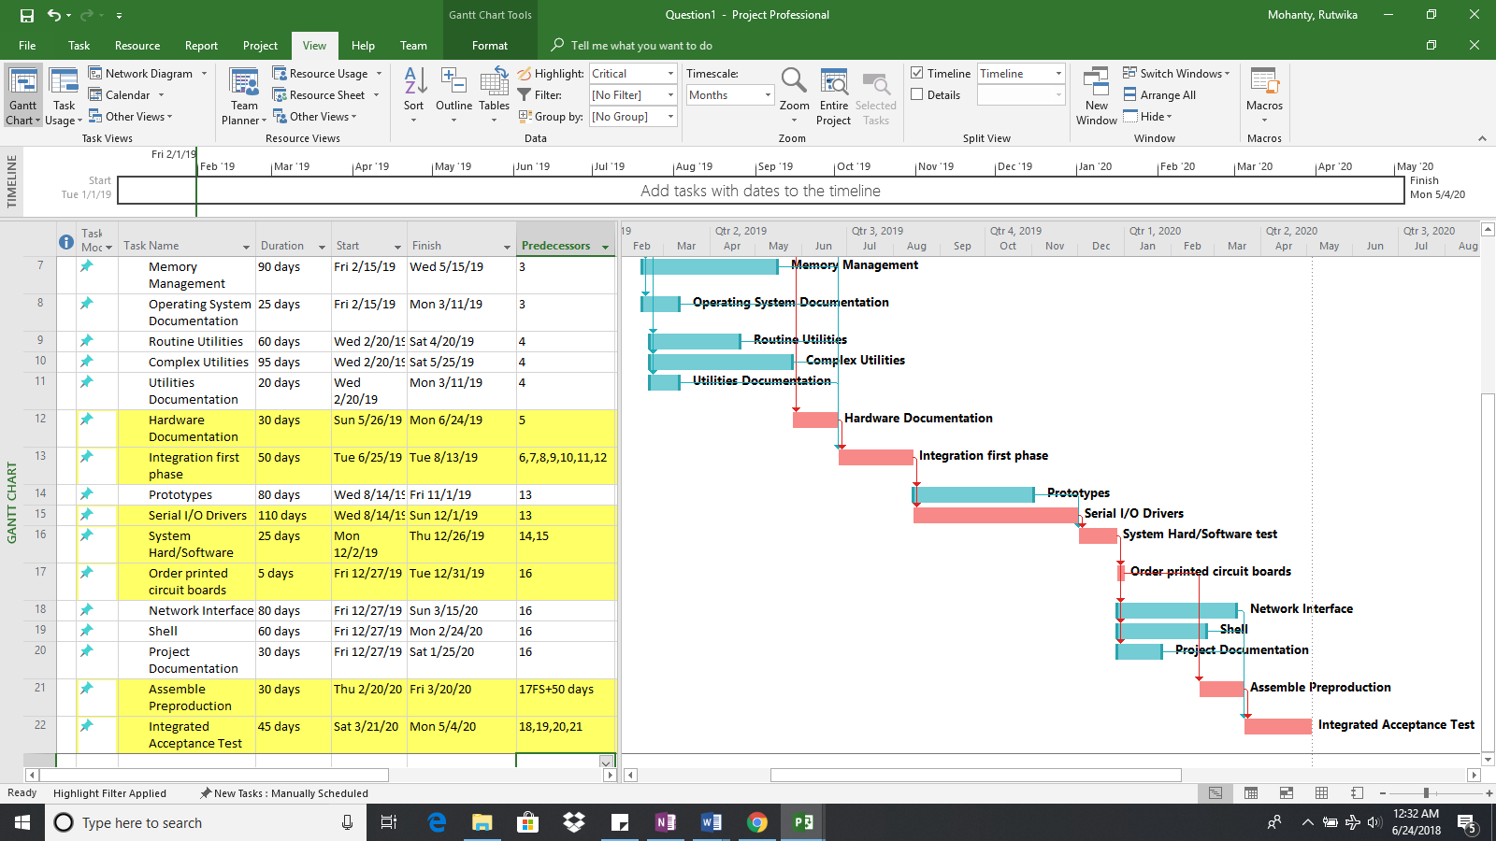

b. Include a screenshot out of ES, LS, EF, LF, and slack times in table form.

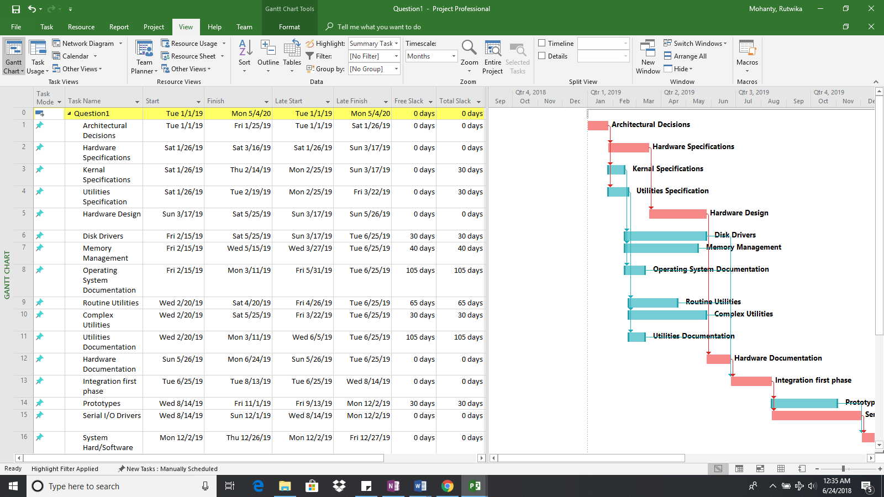

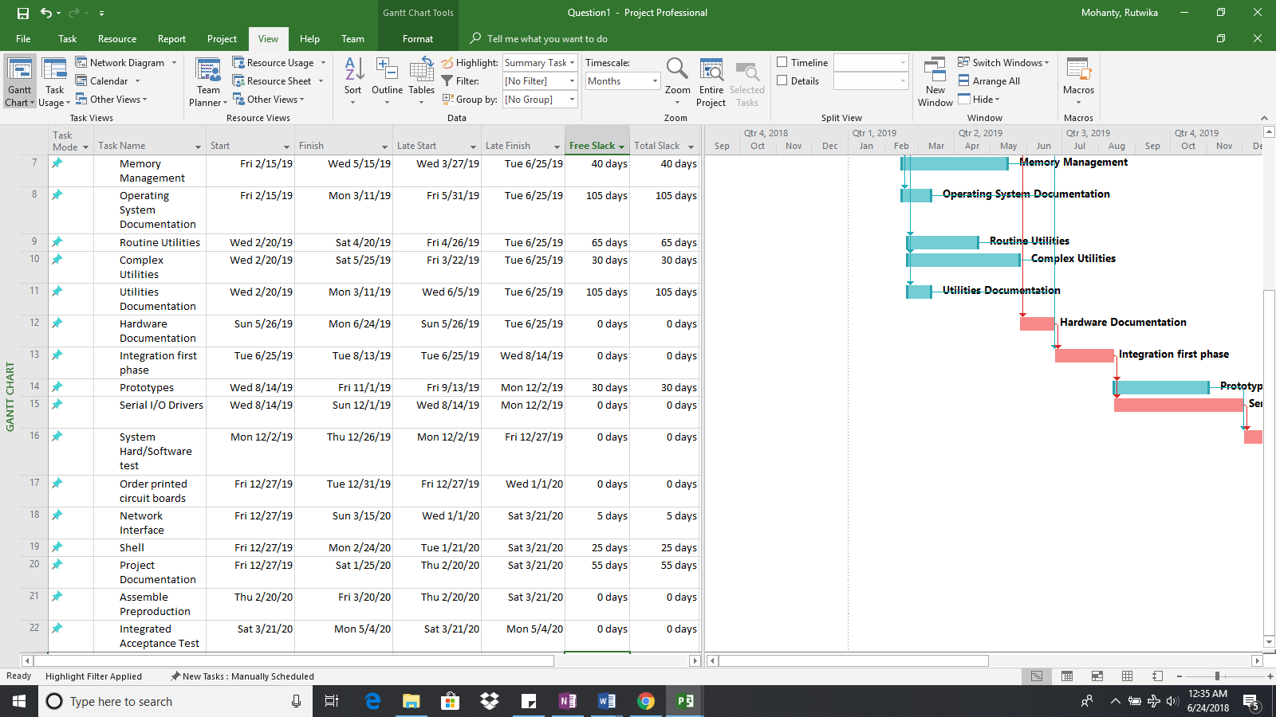

c. What is the scheduled finish date?

Ans: Mon 05/04/2020

d. How many days will the project take to complete?

Ans: 490 days

e. What percent of project activities are on the critical path?

Ans: 10 tasks out of 22 total tasks i.e 45.45% tasks are on critical path.

f. Is it better to have a higher percentage of activities on the critical path or a lower percentage of activities on the critical path? Explain your answer.

Ans: It is better to have a lower percentage of activities on the critical path. Having lower percentage of activities on the critical path increases the free slack available. This in turn can offer better flexibility in scheduling the activities and thus decreases the chances of missing the deadlines.

Question 2 (40 points)

a. After assigning resources, what is the total cost of the project?

Ans: $1,306,000

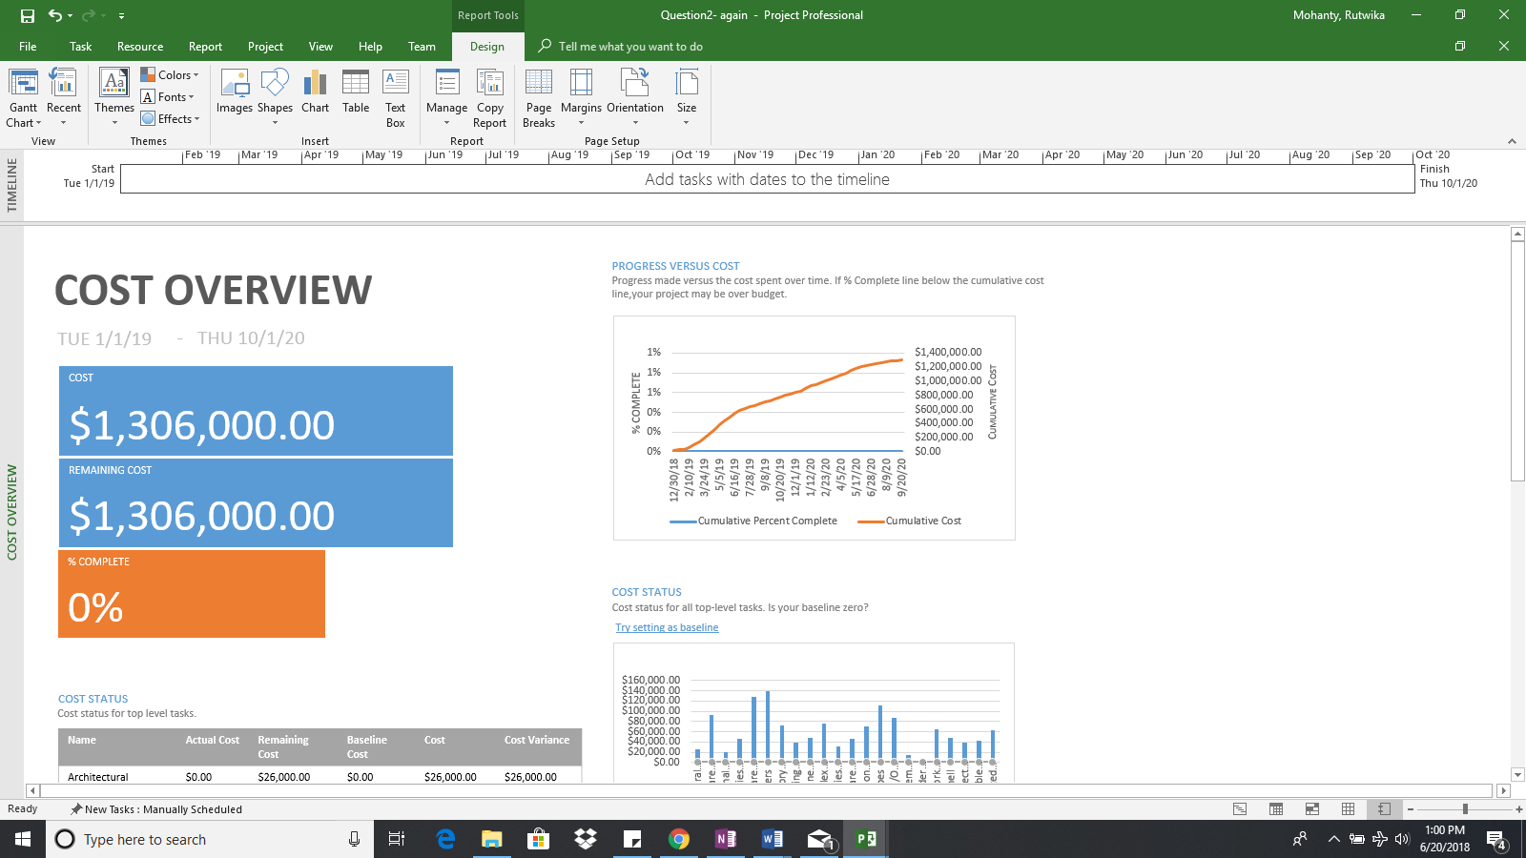

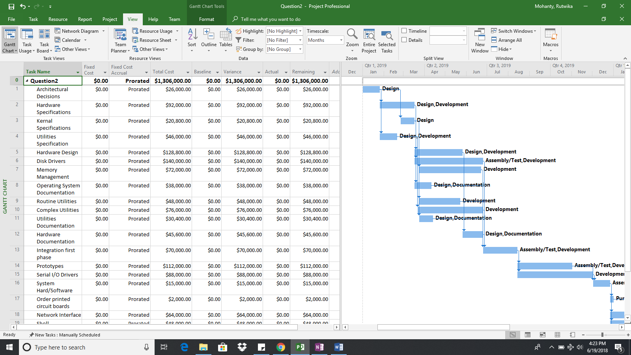

b. Which, if any, of the resources are over-allocated?

Ans: Design, Development and Documentation

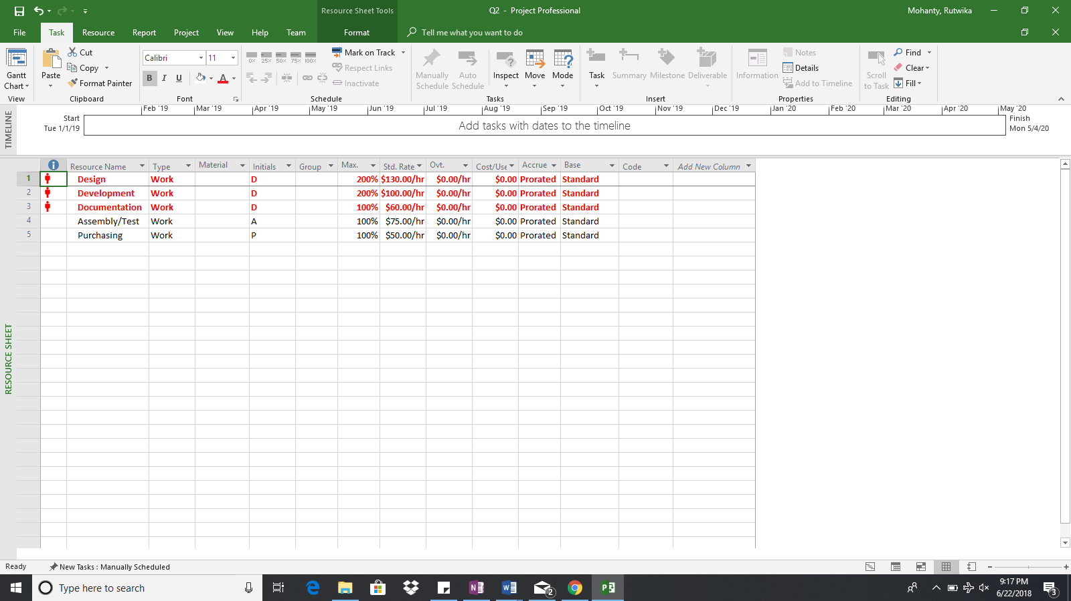

c. Try to resolve the over-allocation problems without extending the duration of the project using the resource leveling feature of MS Project. To level resources without extending the duration of the project, make sure the check boxes for “Level only within available slack” and “Level manually scheduled tasks” are both selected. Also, assume “Leveling can adjust individual assignments on task”, “Leveling can create splits in remaining work”, and “Level resources with the proposed booking type” are deselected. See Figure 3 for the correct leveling settings. After leveling within available slack, which, if any, of the resources are over-allocated?

Ans: Development and Design teams are over-allocated.

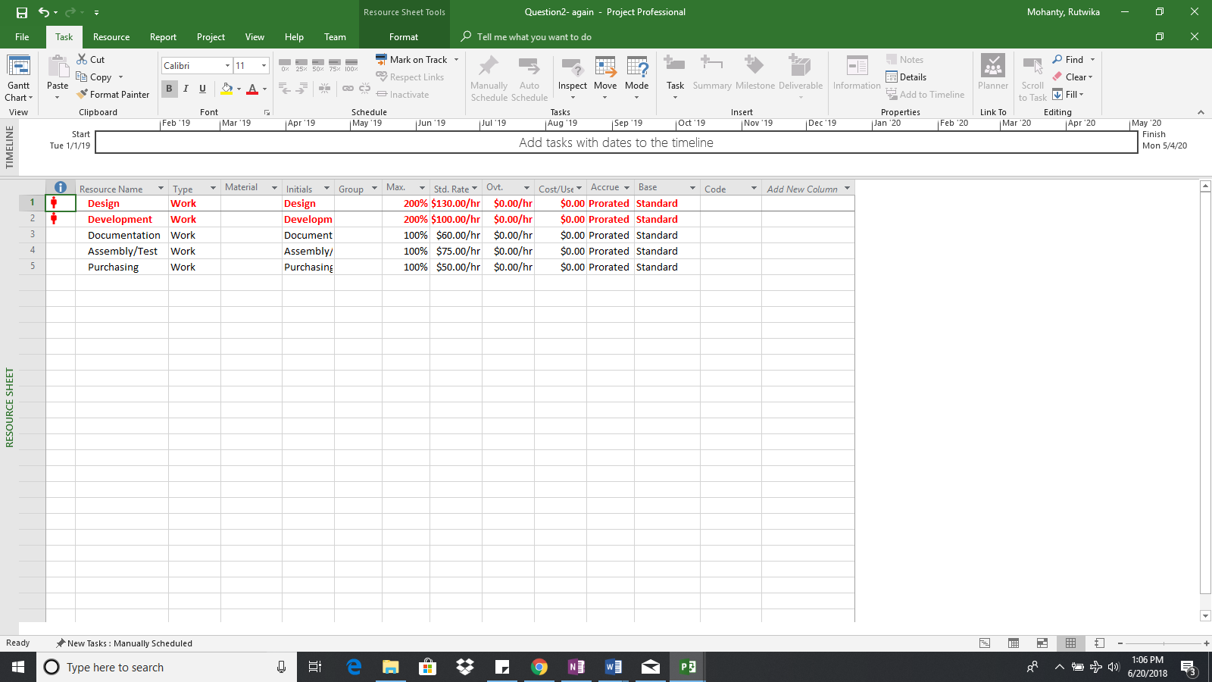

d. Include a Gantt chart and schedule table after leveling only within available slack. Please make sure all tasks are clearly labeled with their corresponding task name.

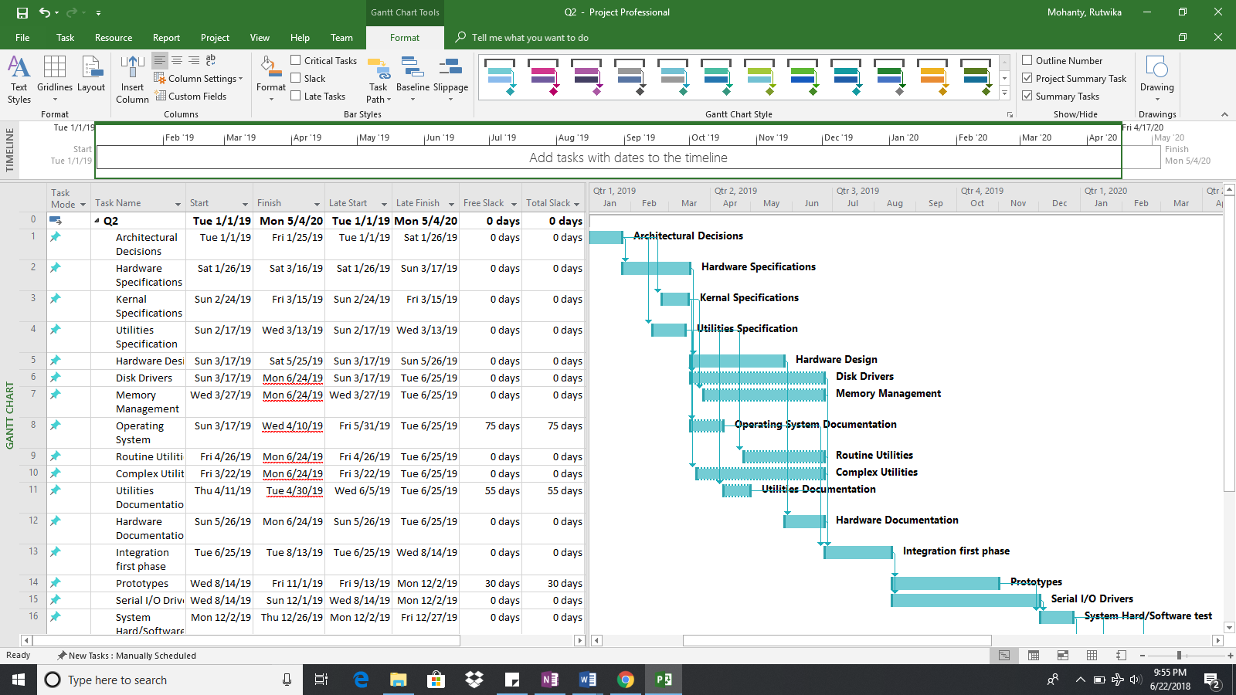

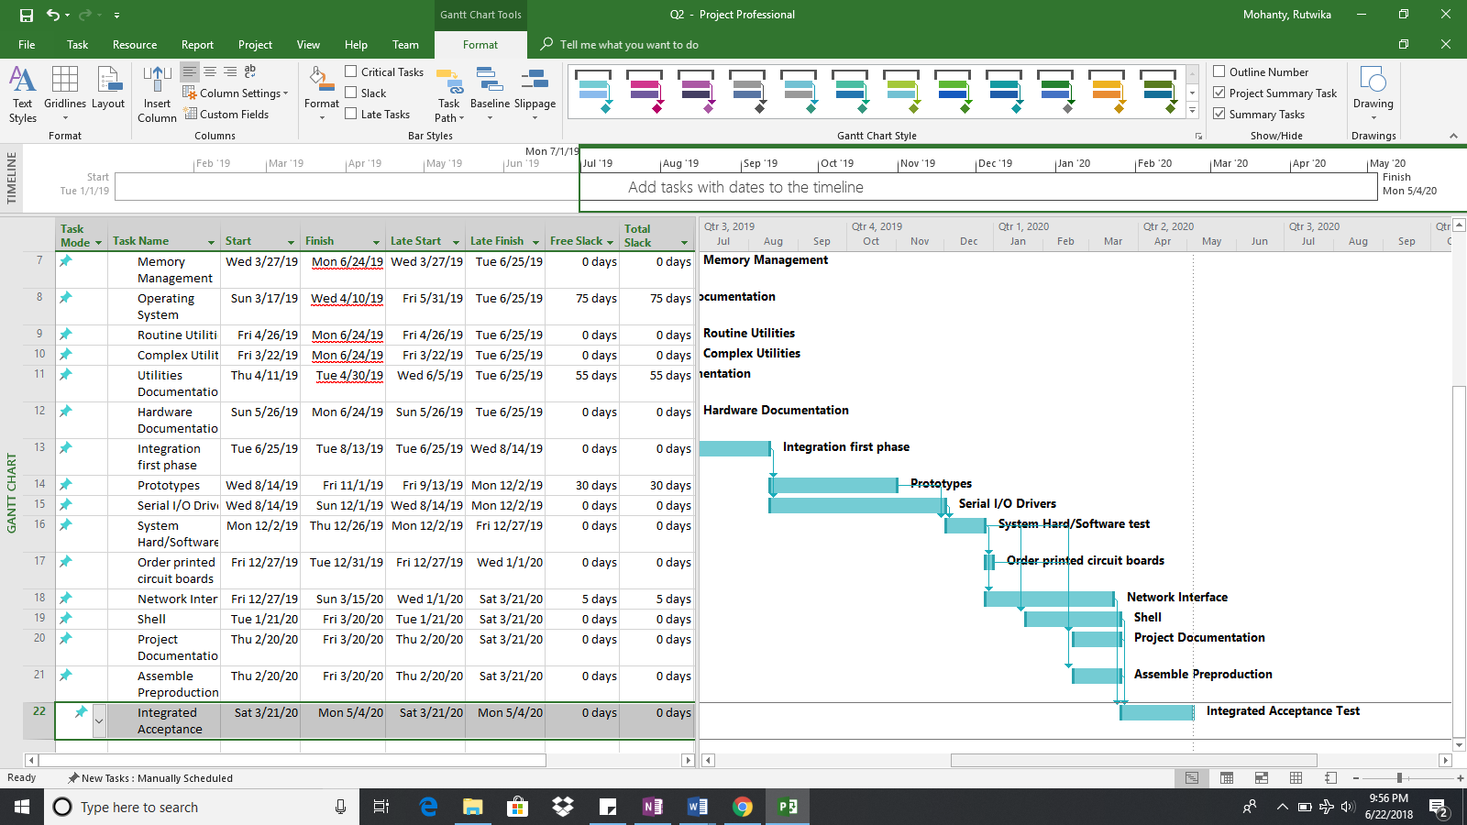

e. What is the impact of leveling within slack on the percent of project activities on the critical path?

Ans: Due to the impact of leveling within slack the number of activities on the critical path increased from 10 to 18. Therefore, 18 out of 22 tasks i.e. 81.81% have become critical.

f. Assume you cannot add additional resources (resource constrained). How many days will the project take after resolving all over-allocation problems? What is the scheduled finish date?

Ans: After solving all the over -allocation problems, the duration of the project increased to 665 days. The scheduled finish date is Monday - 26th October 2020.

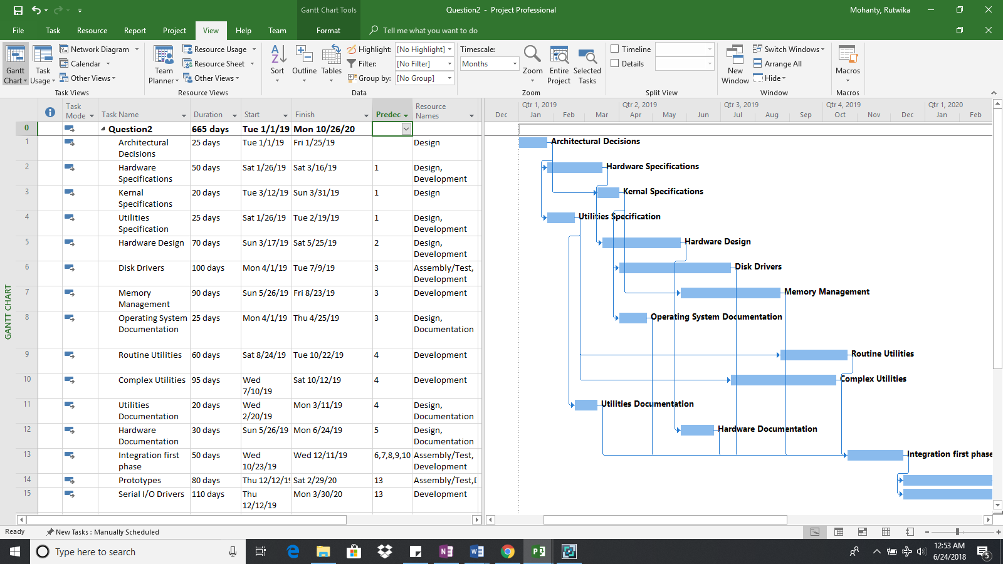

g. How does the schedule in 2f compare to the schedule in Question 1? Why did the number of days to complete the project in 2f increase?

Ans: The schedule of the project was pushed from 490 to 665 days due to following reasons:

* The first question did not consider the resource allocation; thus, the schedule was based on simply the precedence of activities.
* While the second question not only considered resource assignment, but also considered resolving the over allocation of resources problem thereby pushing the deadline further.

h. What is the total cost of the project?

Ans: $1,306,000

Question 3 (20 points)

a. The project sponsor is not pleased with the duration of the project after resolving all over-allocation issues and has requested that you make changes to the project to shorten it. Use the table below and list three activities you would change to shorten the project. Clearly describe each change, the impact the change has on the overall project schedule, and the impact the change has on project cost.

|  |  |  |  |  |
| --- | --- | --- | --- | --- |
| **Activity** | **Description** | **Proposed Change for Reducing Project Duration** | **Impact on Project Duration**  **(Number of days the overall project duration is decreased)** | **Impact on Project Cost (Increase/Decrease/ None/It Depends)** |
| 9 | Routine utilities | Reduced scope of this development activity by reducing activity duration from 60 days to 51 days. Please refer to Figure 3.2. | 627 days | Decrease in cost from $1,282,800 to $1,275,600. Please refer to Figure 3.3. |
| 15 | Serial I/O drivers | Reduced scope of this development activity by reducing activity duration from 110 days to 81 days. Please refer to Figure 3.0. | 635 days | Decrease in cost from $1,306,000 to $1,282,800. Please refer to Figure 3.1. |
| 19 | Shell | Reduced scope of this development activity by reducing activity duration from 60 days to 26 days. Please refer to Figure 3.4. | 593 days | Decrease in cost from $1,275,600 to $1,248,400. Please refer to Figure 3.5. |

After the levelling of over-allocated resources, eight tasks were found to be critical i.e. Architectural decisions, Utilities Specification, Routine Utilities, Integration first phase, Serial I/O Drivers, System hardware and software test, Shell and Integrated acceptance test.

To reduce the number of days to complete the project, the scope of tasks that are taking maximum number of days to complete such as Serial I/O Drivers, Routine utilities and Shell is reduced only to the limit where the number of critical tasks doesn’t get increased or any new critical task is not introduced.

Figure - 3.0

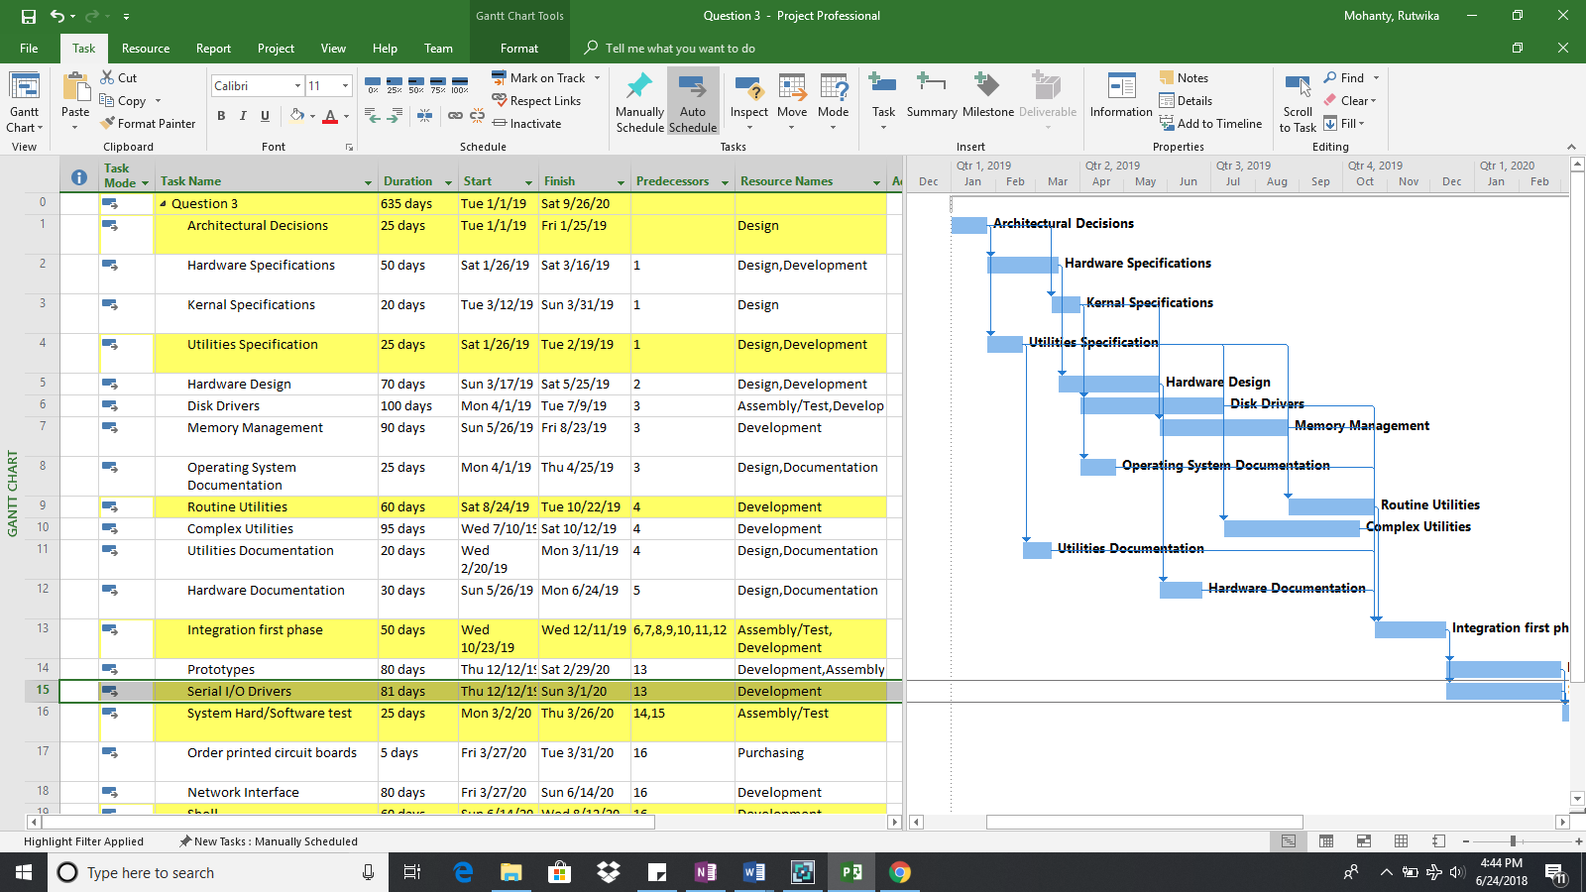

Figure – 3.1

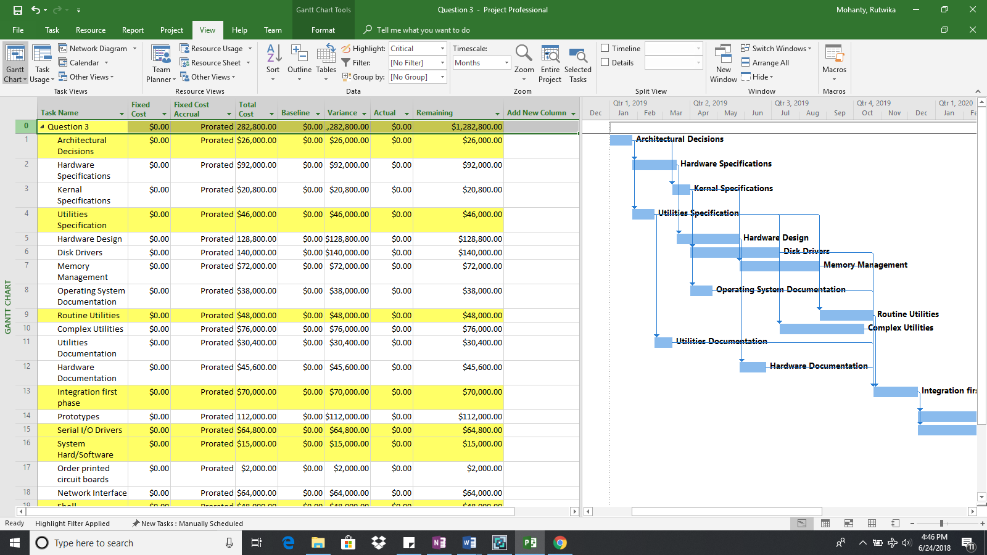

Figure – 3.2

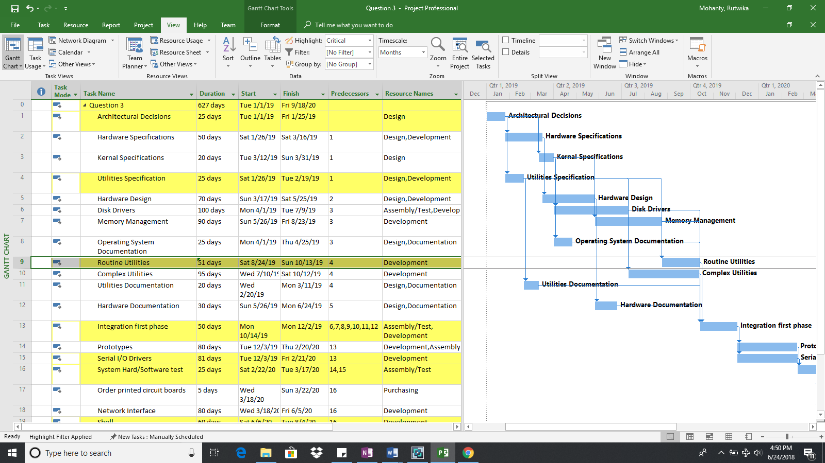

Figure – 3.3

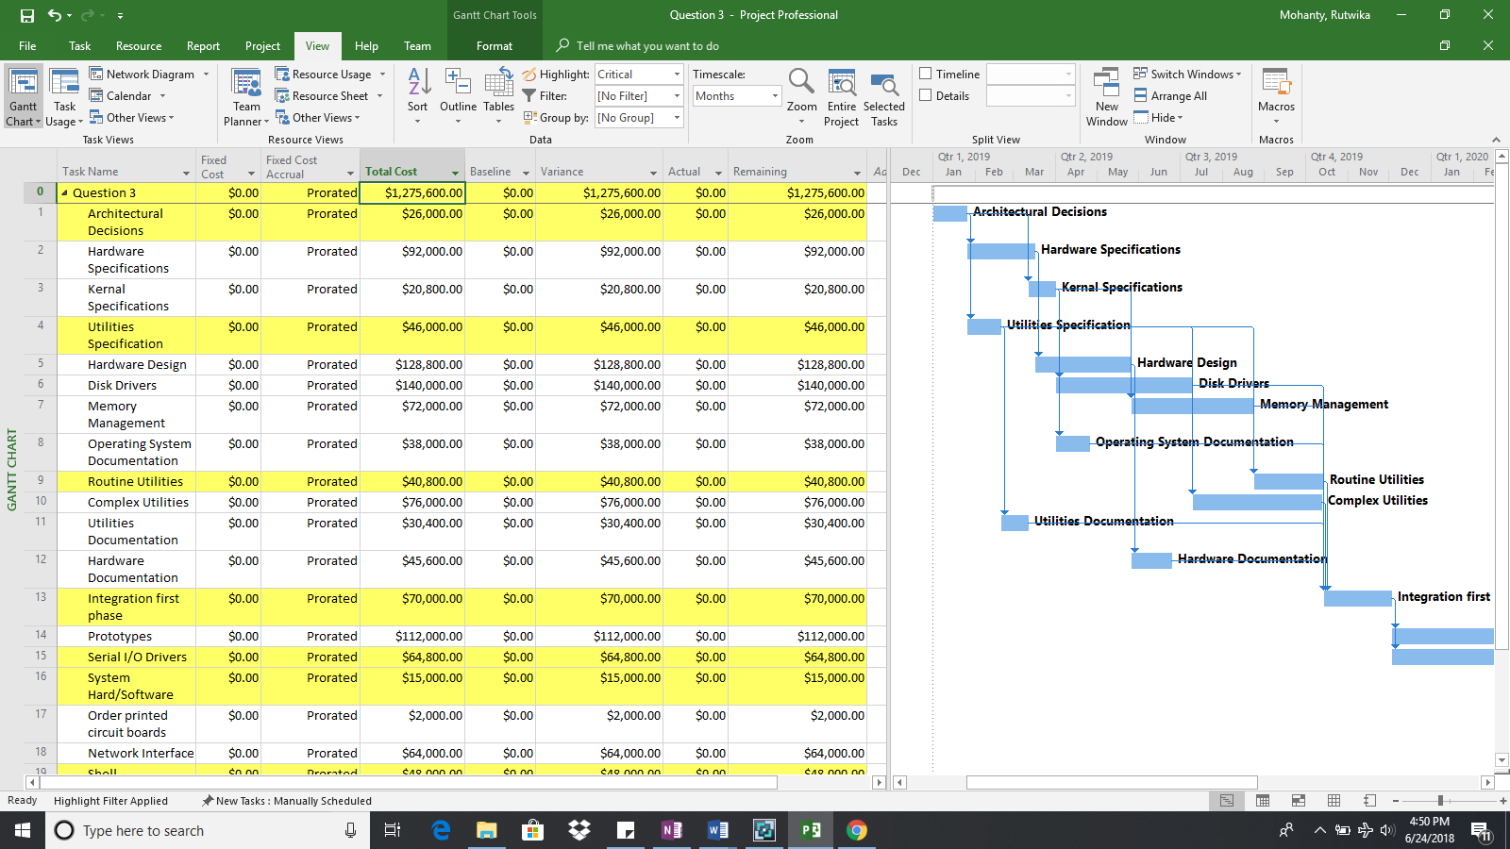

Figure – 3.4

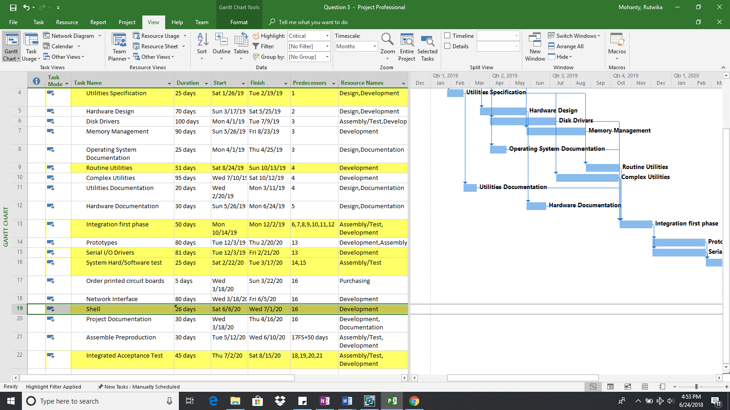

Figure – 3.5

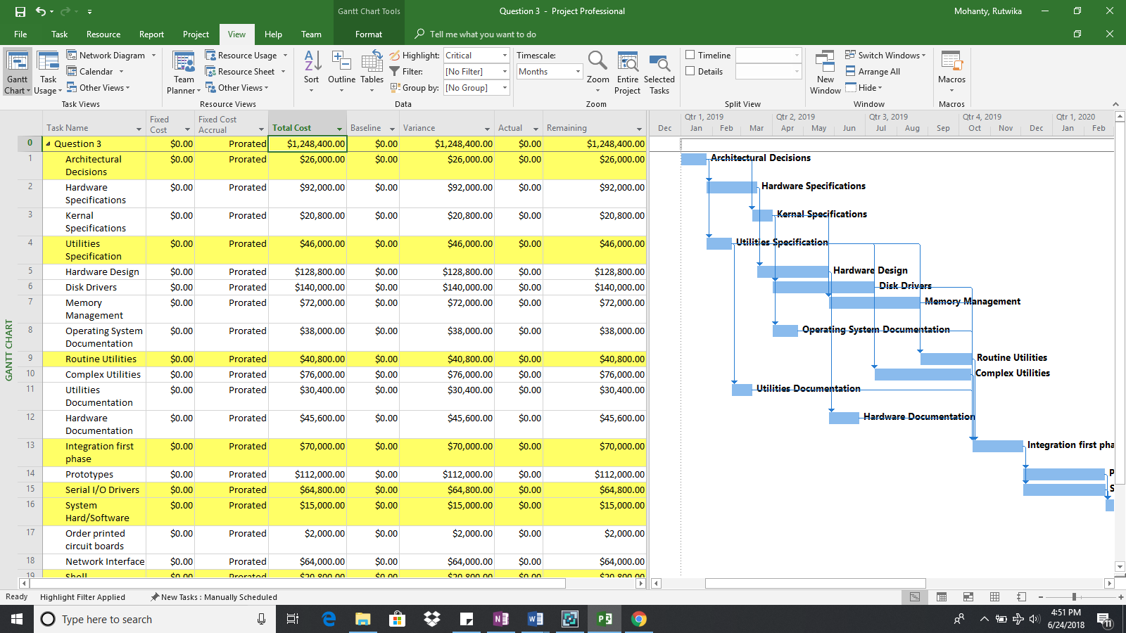

b. What is the finish date of your revised project?

Ans: Saturday – 15th August 2020

c. What is the cost of your revised project?

Ans: $1,248,400